"



”

James Fletcher

I am a ne'.\' dr”' er and I '.\'ant to Luy a the ap, afford able and sma c ar.’

Actions / Events

Involved Parties

|  |  |  |  |  |  |  |
| --- | --- | --- | --- | --- | --- | --- |
| Customer Thoughts | * 4ngry | * C' er'.the med | Excited | * Unsati*fied | * Troub IesonJe | Glad |
|  |  | * E x ited | C oncerne d | * Lack fe azure* |  |  |



games Fletcher _

Ne.it al Unlapov

* Lookincl at ad' ert”seme nt
* £J arketing
* Re: ea r hin g a desire d car
* £J arketing

Te°t dri‘.'”n g car:

Sale*



* £J aking choice
* £J arketing
* Sale*
* 4 count”n g
* Ser‘.'”ce Dep art rr em
* Settling payment
* 4 count”n g

Seeking help

Sale*





Brand and Value Pemeption



Gap / Opportunity / Celebration

Potential Solutions

* D onI trust dealers
* E:t abIi°h reputati on
* P ace TV ad
* Sp oke*p erson *mately
* 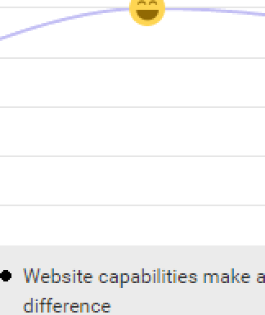Profe:*ionaI weL*ite
* Re‘.'”ev,' and re de*ign current company \‘/ebs”te

Pro' iding a good experience at the frst touch point Jr” es rrore vi:it:

Ta rget ed I est”n g : upp art

Dedicated :taff that ass”sts the cu*t orr er throughout the test dri‘.'e proce°s

* Sale* *kill* and appro ac h ' ary
* G oo J s ales : kill:
* Train”ng
* Too much time on paperv,'ork
* ReJuce paper work
* Pre-\‘/ritten forms



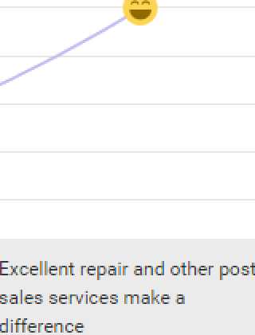£J ore k ind* of * er.'ices

Strengthen the existing ser' ice p orfolio

Introduce ne'.\' ser' ice ReJuce rr anpower by not to pro ide unpopu ar *er ”ce*